Labelling and Numbering Prints
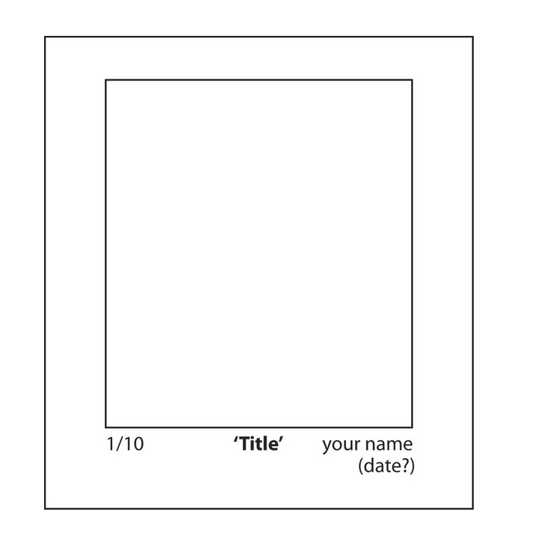
- Sign your prints using a pencil not a pen
- Sign your name, initial or monogram on your prints below the bottom edge of the plate on the right-hand side (along with date if desired)
- Mark the edition number below the bottom edge of the plate on the left-hand side
- Add a title in the middle between the signature and the edition number. Titles are often written in inverted commas – ‘Title’
An ‘edition’ of a print is a limited set of identical prints made from the same plate. Editioned prints must be identical. Editions are labeled with the particular print number then a slash (/) then the number of total prints in the edition.
Eg. 1/10 - print number 1 from a total of 10 identical prints.
35/75 - print number 35 from a total of 75 identical prints.
A/P (Artist’s Proof) – The first print pulled. It allows the artist to see if changes need to be made in the print and is usually kept by the artist.

